Case study

1. Circuit breaker

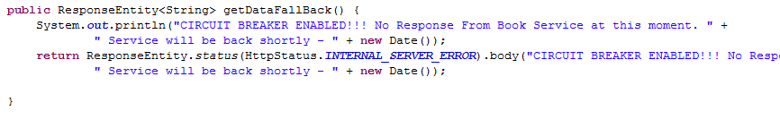

1. Registration and Discovery using Eurekha

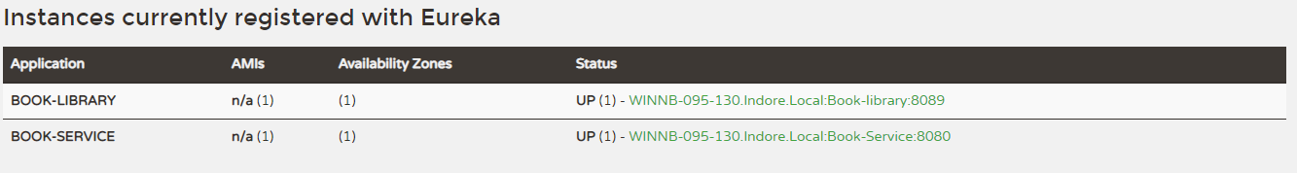

1. Use of Feign.

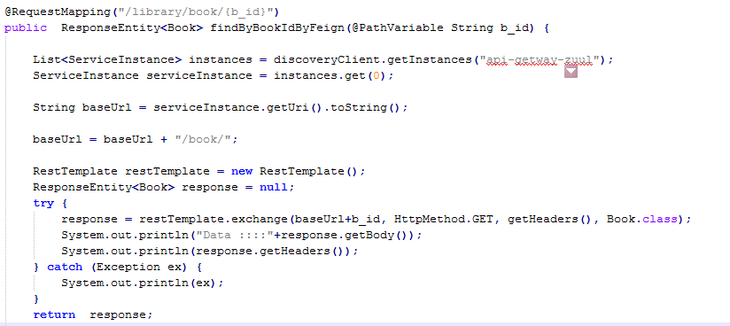

1. Use of Ribbon.

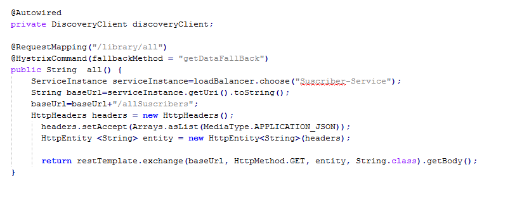

1. Use of Zuul.

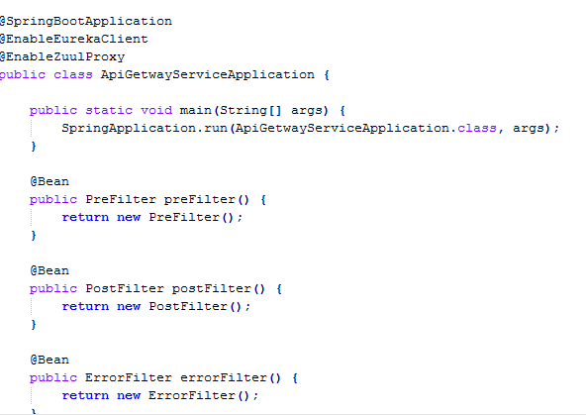

1. Database.

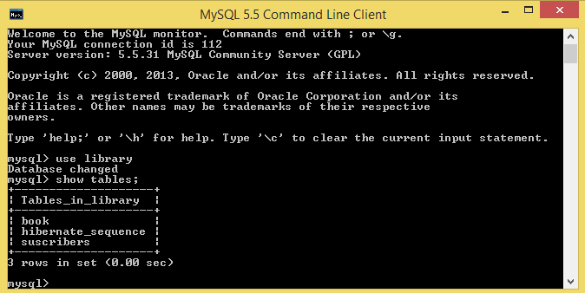

1. Junit test case

